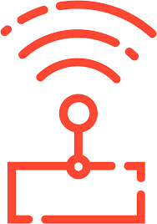 Bonrix IOT Monitoring Solutions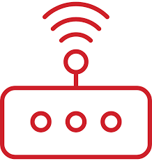
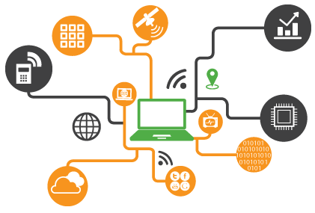
IoT devices, or any of the many things in the internet of things, are nonstandard computing devices that connect wirelessly to a network and have the ability to transmit data.

Applications:
- IoT Gateway / Machine to machine (M2M) hardware – Reports the states of analog/digital inputs & also RS-485 modbus slaves over internet or SMS.
- GPRS/3G/SMS based Remote Alarm Monitoring & Reporting.
- Energy/Power monitoring.
- Remote Temperature/Humidity monitoring.
- Remote Water & Liquid level monitoring & control.
- Monitor your Equipment/Machinery & Process remotely.
- Remote Control – Turn ON/OFF equipment & machinery from remote locations.
- Get alerts when specific events occur such as Fire, Pump failures, Machine failures, Low fuel/fluid levels, Temperature/Humidity alerts etc.

Types oF IOT Device:-

1)Home Automation IoT Devices.

2)Industrial IoT Devices.

3)Miscellaneous IoT Devices.

4)Development Boards IoT Devices.

5)Virtual Reality (VR) and Augmented Reality (AR) IoT Devices.

1)Home Automation IoT Devices 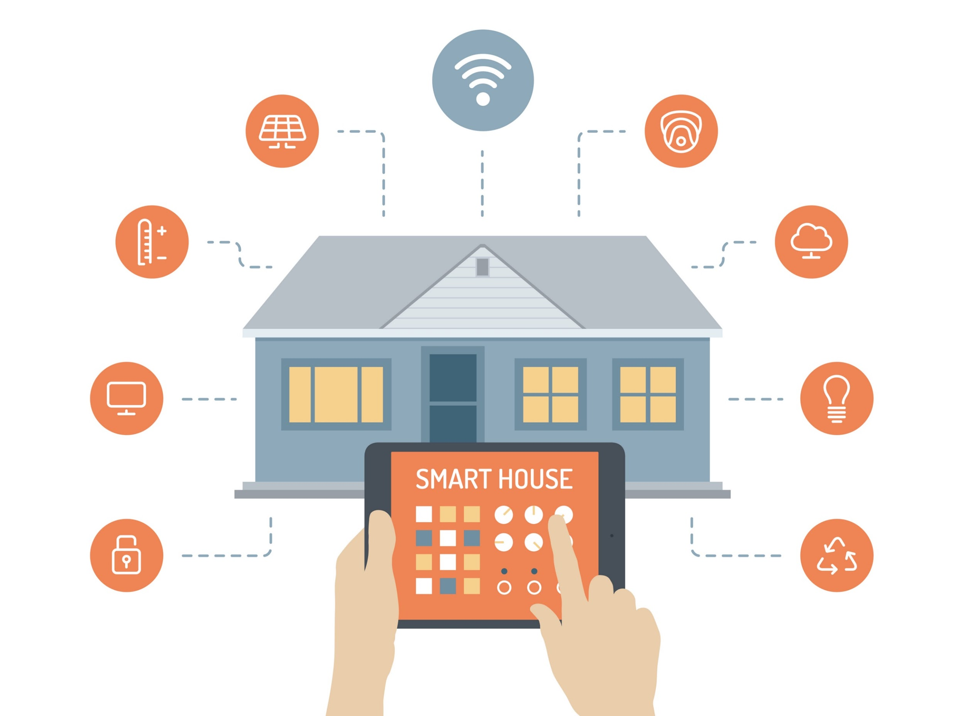

The IoT based Home Automation will enable the user to use a Home Automation System based on Internet of Things (IoT). The modern homes are automated through the internet and the home appliances are controlled. The user commands over the internet will be obtained by the Wi-Fi modems.

2)Industrial IoT Devices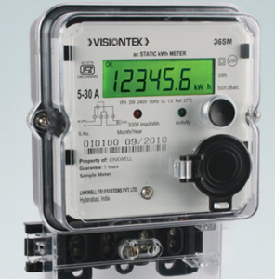

The vision of complete digitalization is based on nothing else than the fact that the real world is simulated in a virtual reality. To this end, data and information is continuously read from sensors, electronic devices, machines, and systems and transmitted to intelligent systems that create a digital image of the actual environment.

3)Miscellaneous IoT Devices 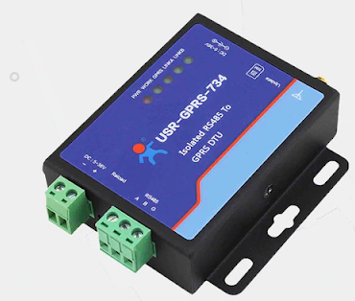

IOT technology can be integrated in various things like machines, controllers, sensors, SCADA, ERP,CRM, shopfloor, and unstructured data. The resulting mathematical models provide you actionable insights helping you to improve quality and reduce cost.

4)Development Boards IoT Devices.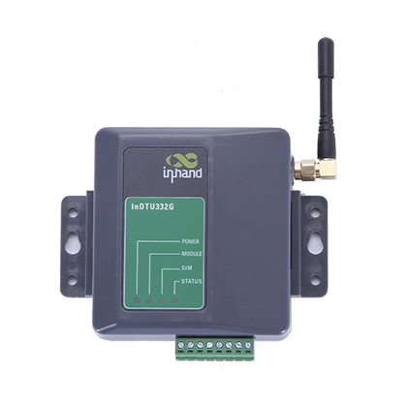

Developers will have to choose from microcontroller-based boards, System on Chip (SOC) boards, Single-board Computers (SBC) and purpose-built boards with support for Smart Bluetooth and WiFi.

5)Virtual Reality (VR) and Augmented Reality (AR) IoT Devices.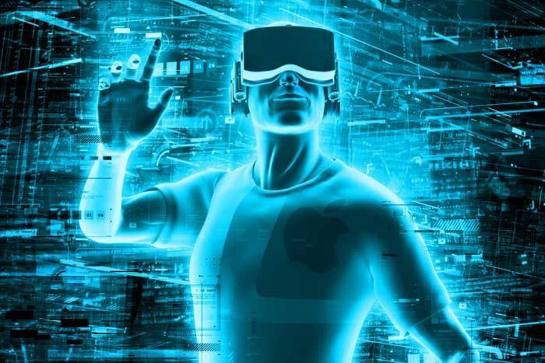

Implementing AR applications into a real-life work context can bring in information. Workers can be provided with step-by-step instructions through real-time video guidance from an expert.
Application in IOT Devices.

- Energy Monitoring.
- Solar Monitoring.
- Environment Monitoring.
- Smart Grid.
- Cold-Storage.
- Generator.
- Street Light.
- Water Treatment.

1)Energy Monitoring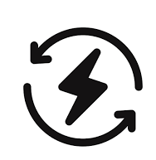
Monitoring through meter is used to monitor units consumed and transmit the units as well as cost charged over the internet using wifi connection. This allows user to easily check the energy usage along with the cost charged online using a simple web application. Thus the energy meter monitoring system allows user to effectively monitor electricity meter readings and check the billing online with ease.

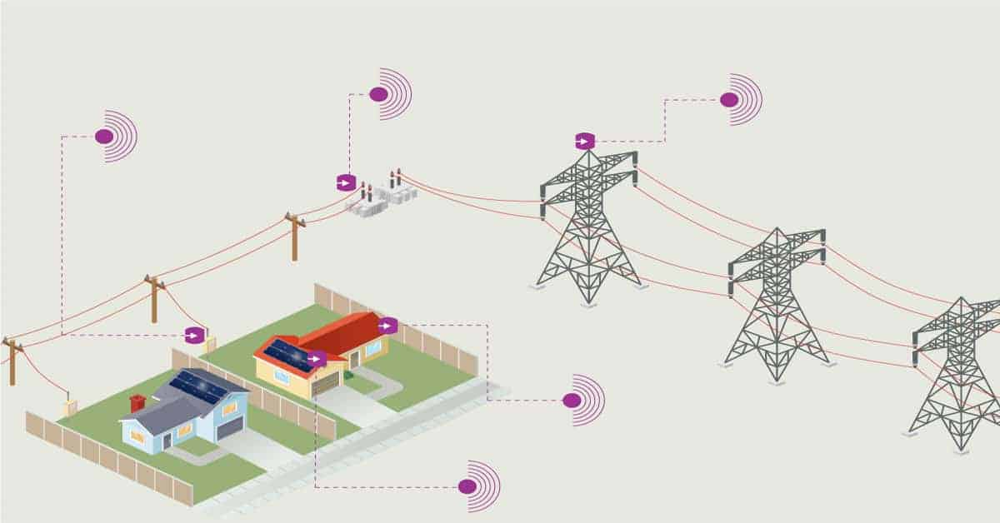

2)Solar Monitoring 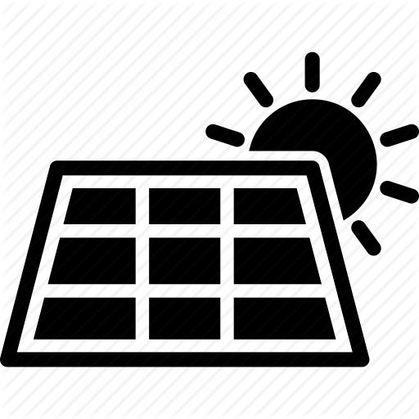

Solar is renewable source, demand of electricity is increased day by day. Solar energy is tough out the year and solar power plants need to be monitored for optimum power output.
This helps efficient power output from the power plants while monitoring for faulty solar panels, connections, and dust accumulated on panels lowering output and issues affecting solar panel performance.

3)Environment Monitoring
Environmental monitoring is a tool to assess environmental conditions and trends, support policy development and its implementation, and develop information for reporting to national policymakers, international forums and the public.
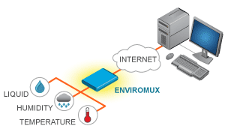

4)Smart Grid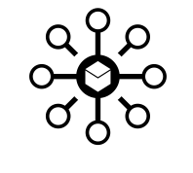

Capture data at every point of your grid to make better decisions. True two-way communications and smart devices extend your real-time capabilities to include distribution automation, demand response and distributed energy resources (DER) technologies.
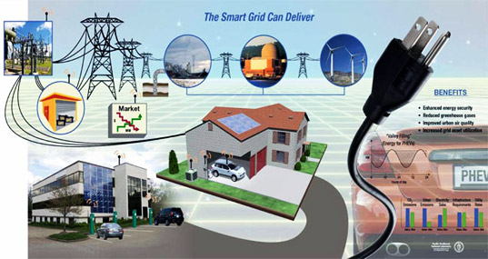

5)Cold-Storage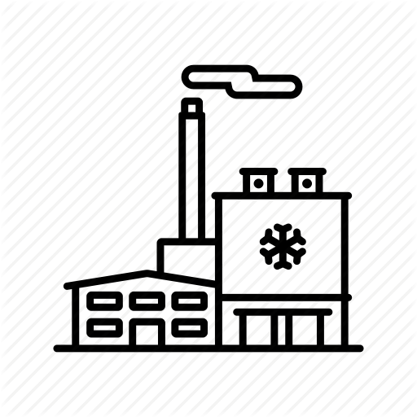

Tap into the cold storage industry, on-site checking and monitoring data is time consuming and considered as an inefficient process. To meet the majority of industrial demanding needs, wireless technology becomes an integral part and it takes some major steps forward.
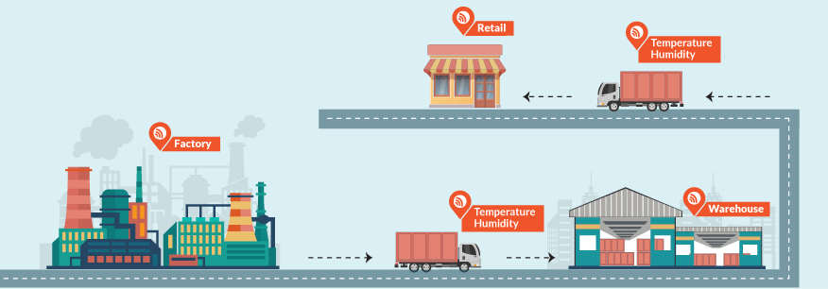

6)Generator

IOT helps Diesel Generator OEM's to offer preventive maintenance as a service and innovate on their revenue model at a time where market share is static or dropping.

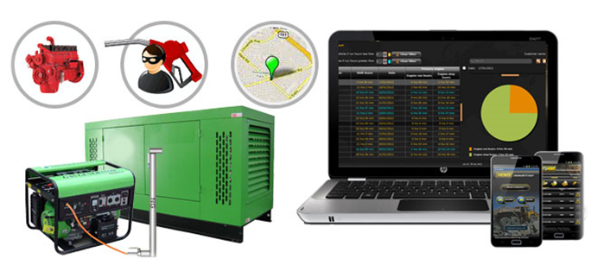

7)Street Light

IOT based street light monitoring and controlling system to ensure, low power consumption, consumption monitoring, instant faulty light detection and light dimming as per external lighting conditions.The system also allows the controller/monitoring person to check estimate power consumptions as per current intensity of light as well as predict monthly power consumption.

8)Water Treatment.

IoT in water treatment uses the concept of smart sensors installed at various points in the water system. These sensors collect data and send it back to the monitoring systems. This data could include, water quality, temperature changes, pressure changes, water leak detection, and chemical leakage detection.

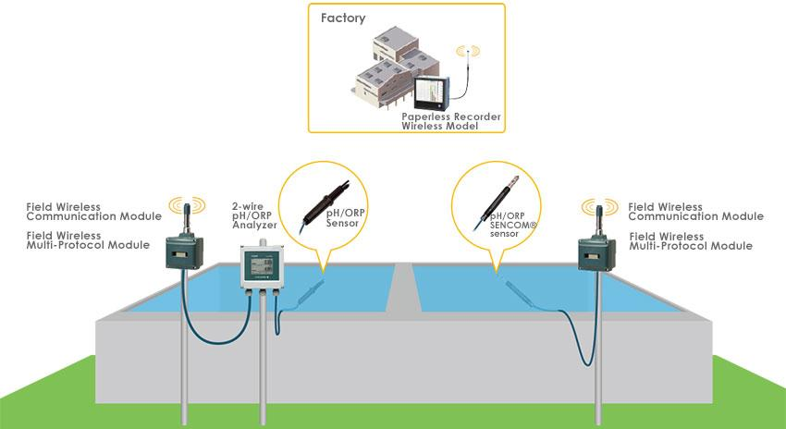

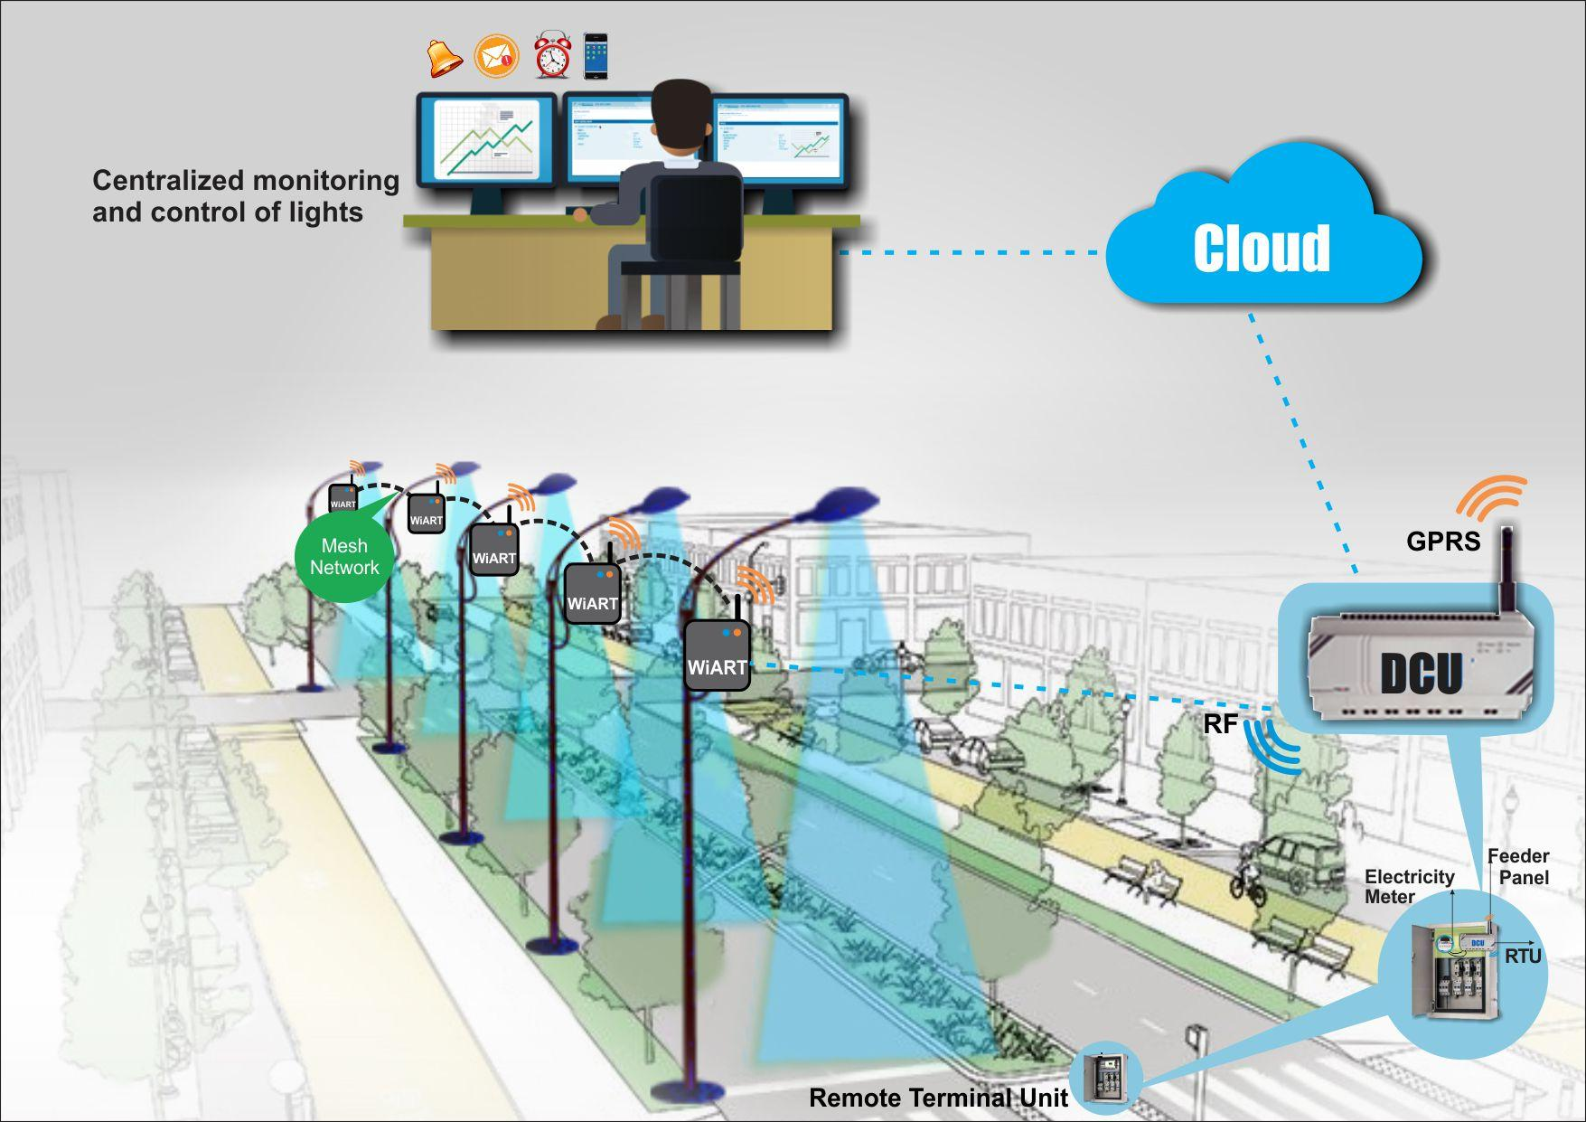

Delta Software Details

1)Admin Panel

This panel will act as supreme to manager as well as to user

Key Features:
1)Adding Devices
2)View Device Profile vise Device
3)Adding Manager,user
4)Device Allocation
5)Other panel Login access

a)Manager List :-
Admin can view all manager with add,modify,delete and active.deactive
functionality.
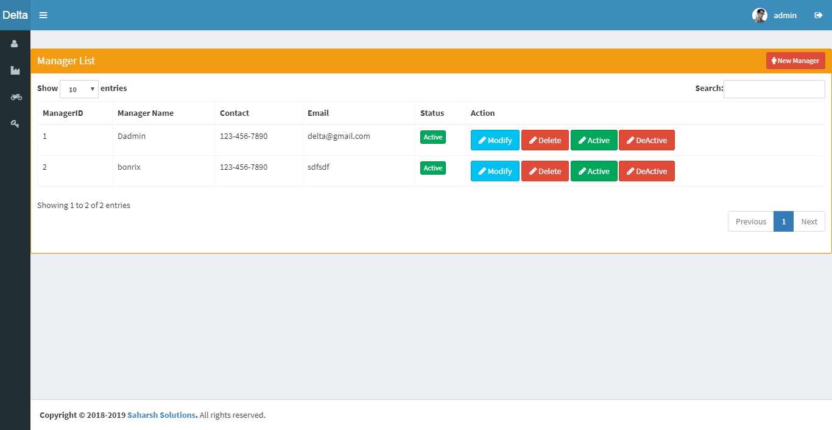

b)Device List:-
Admin can view all device with adding,modifying,delete add assign device
to manager features.
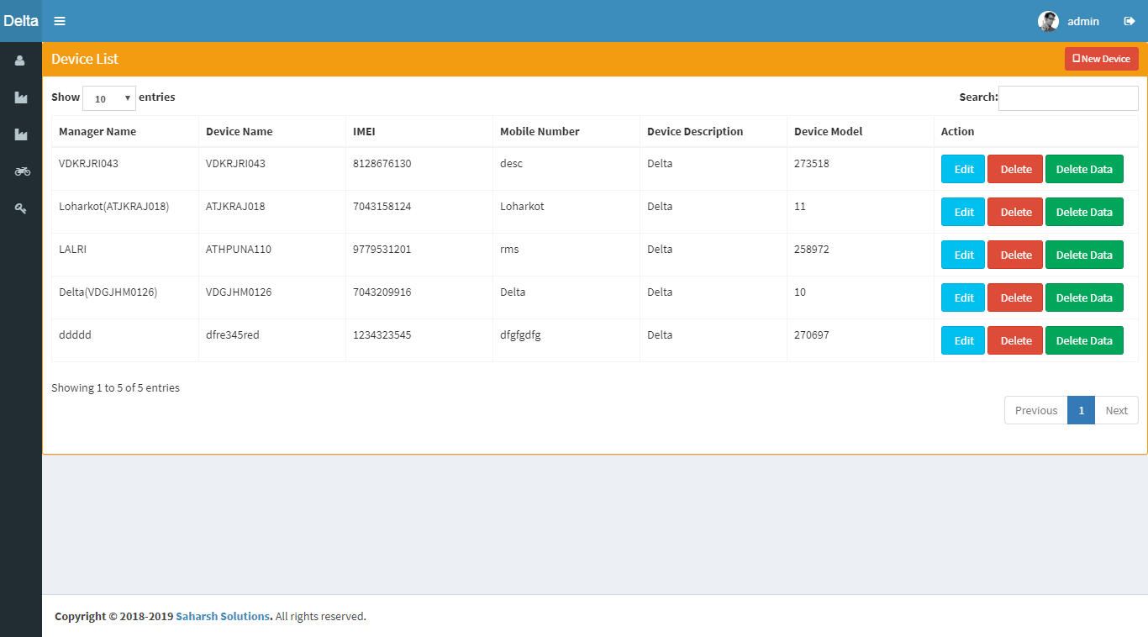

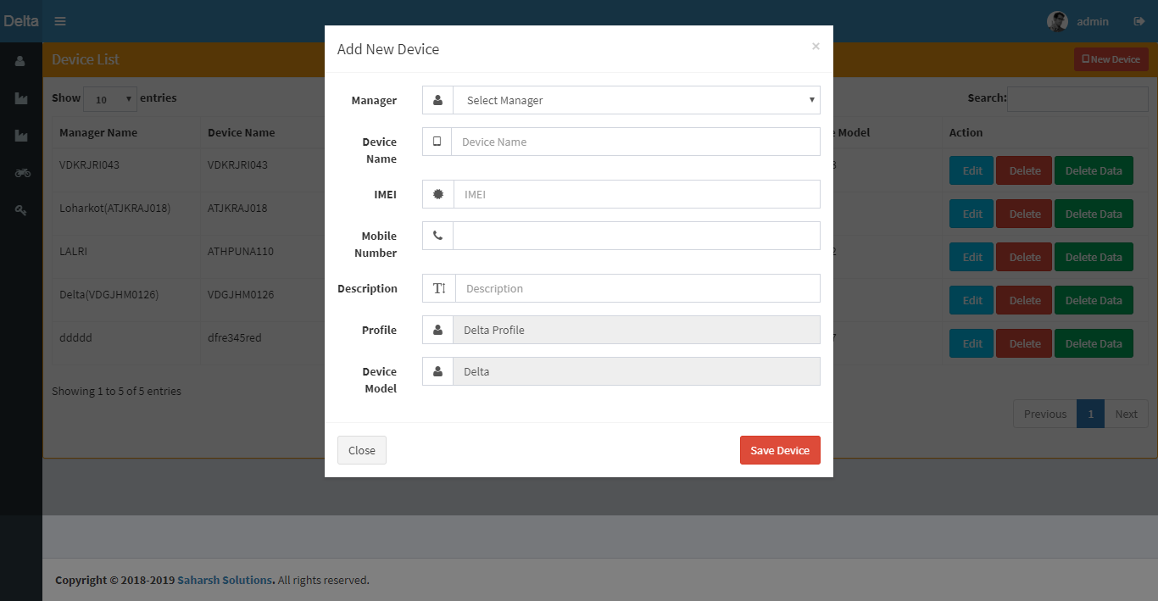

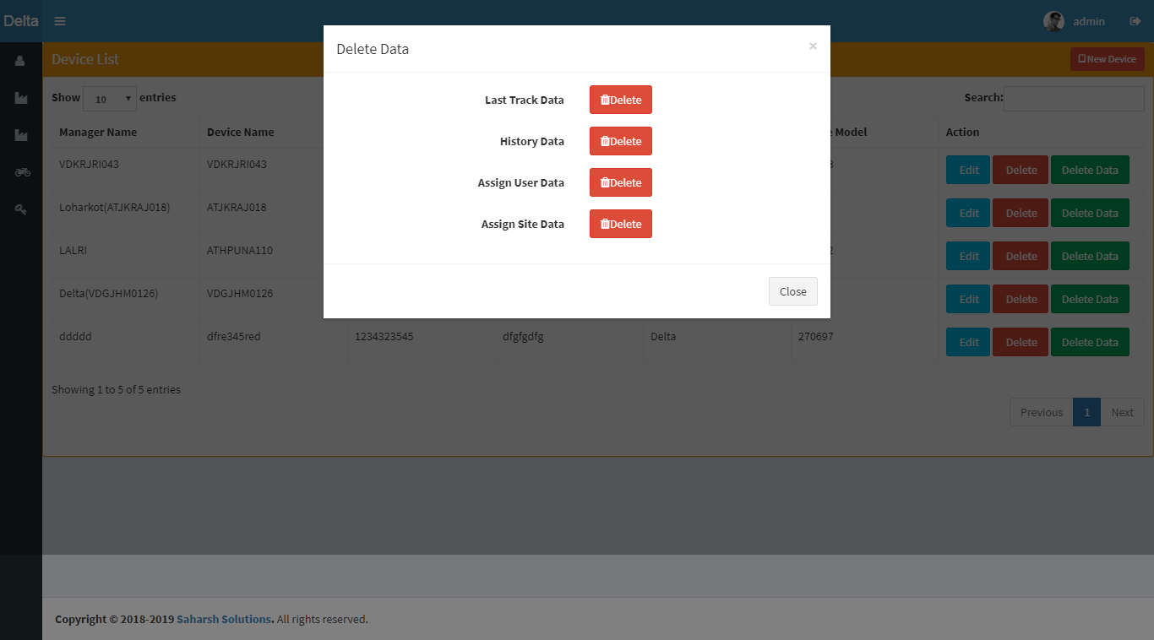

c)Profile List:-
Profile view provide whole details of all devices profilewise with raw
json,formatted json,history,last track with refresh feature.

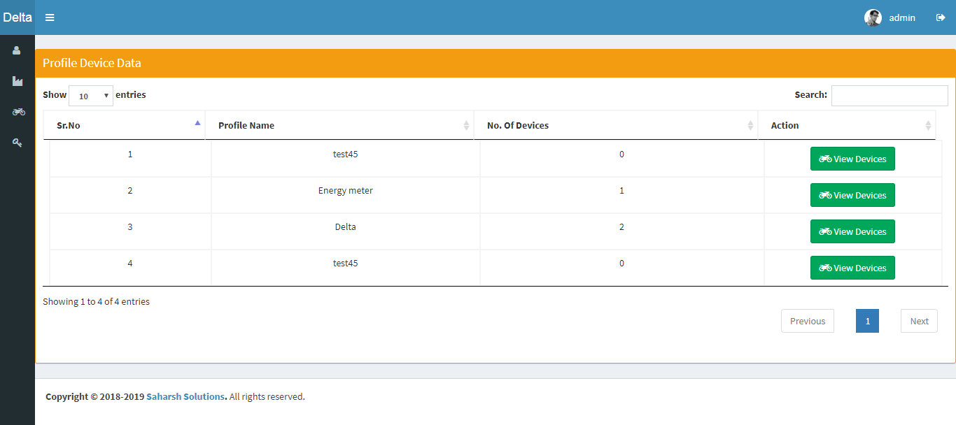
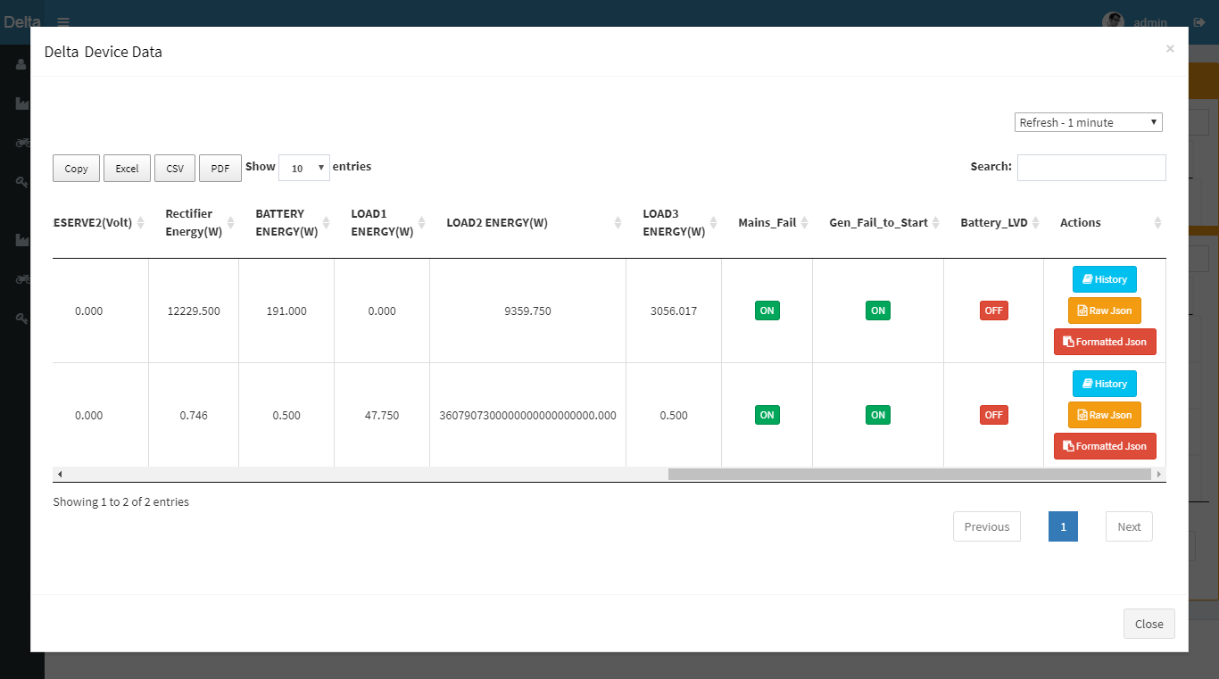
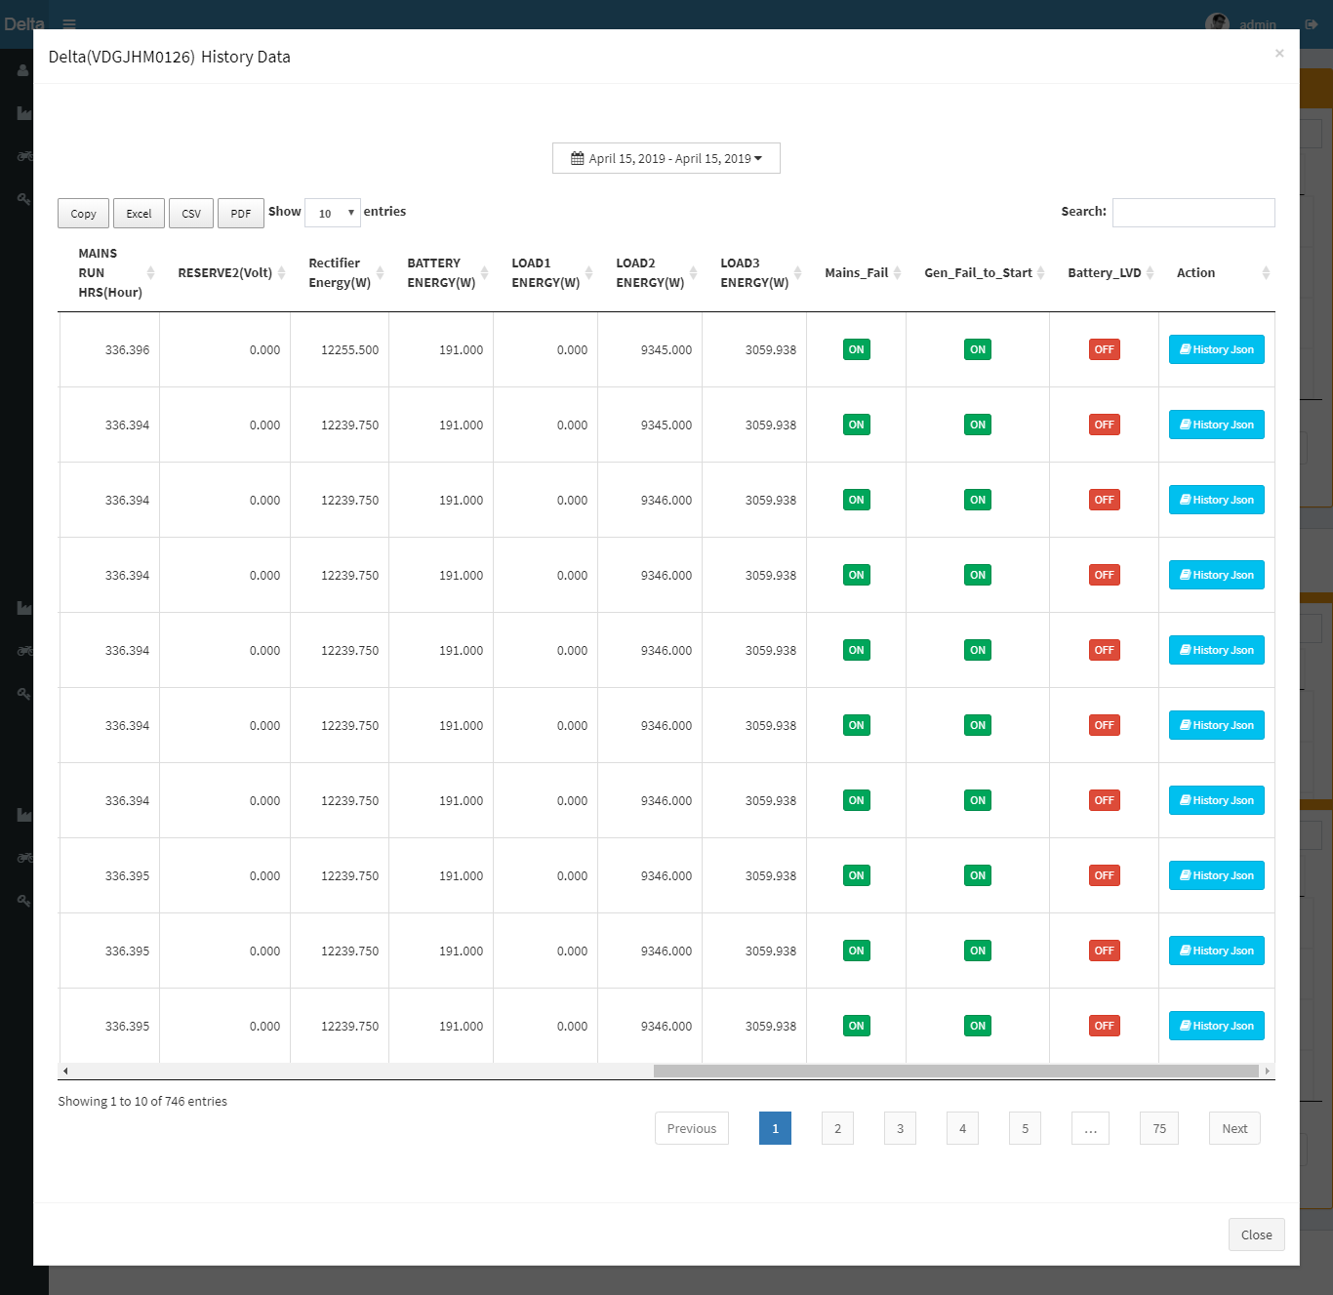

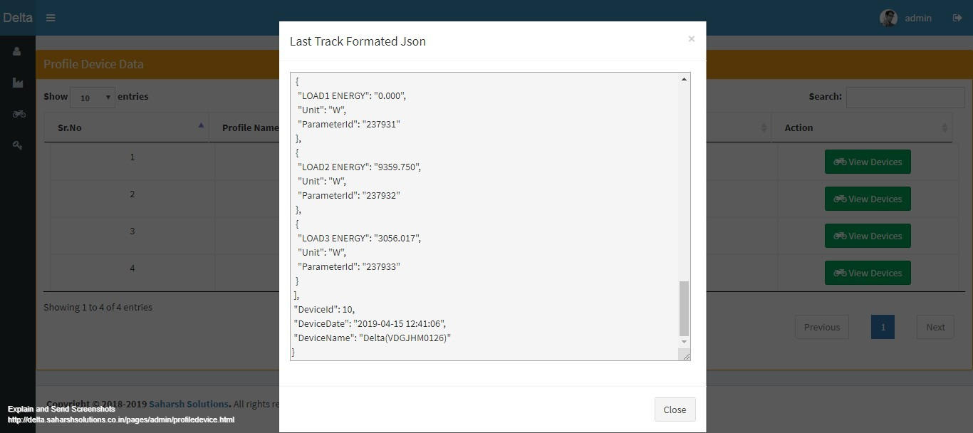

d) Reset Password:-
Admin can reset password for security reasons.
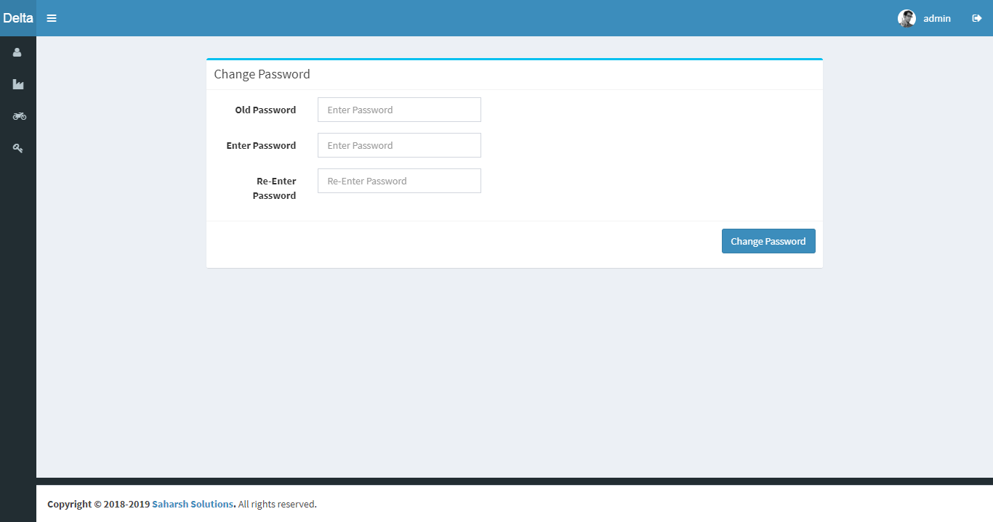

2)Manager Panel

Manager is middle player between both admin panel and user panel.

a)User List:-

It gives list of all user which comes under manager. It allows manager
to access user panel with login functionality and some other features like
add,modify,active/deactive And assign site.
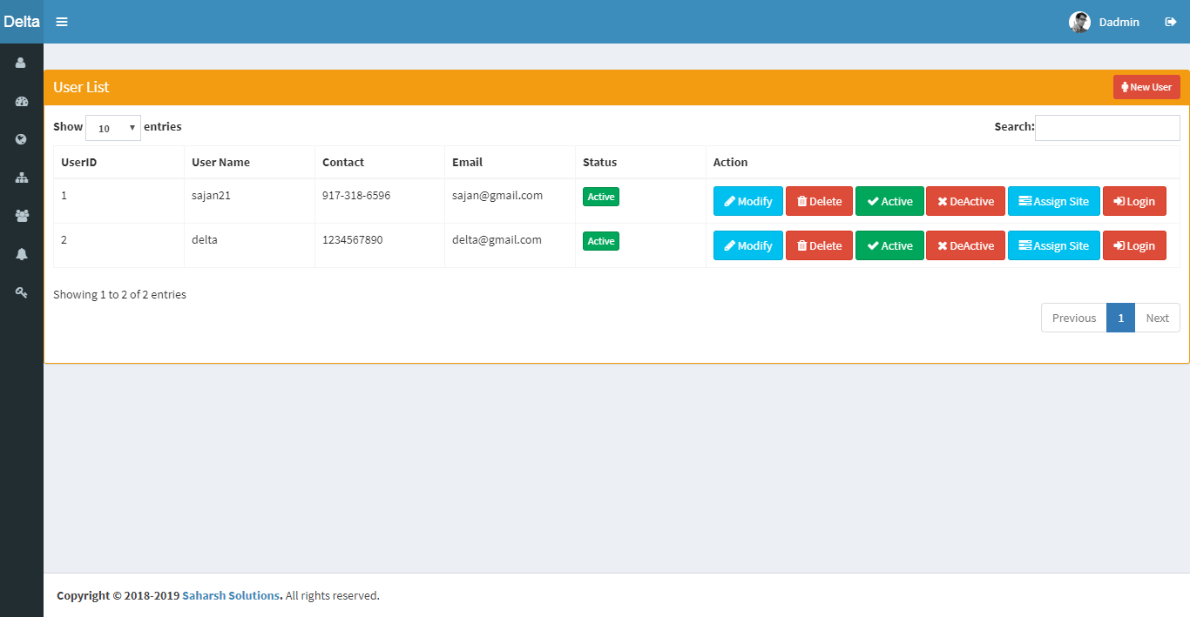

b)Device Data:-
It gives updated data of all device which comes under manager from last
track with refresh data functionality.manager can also see history data of
particular device on click history button.
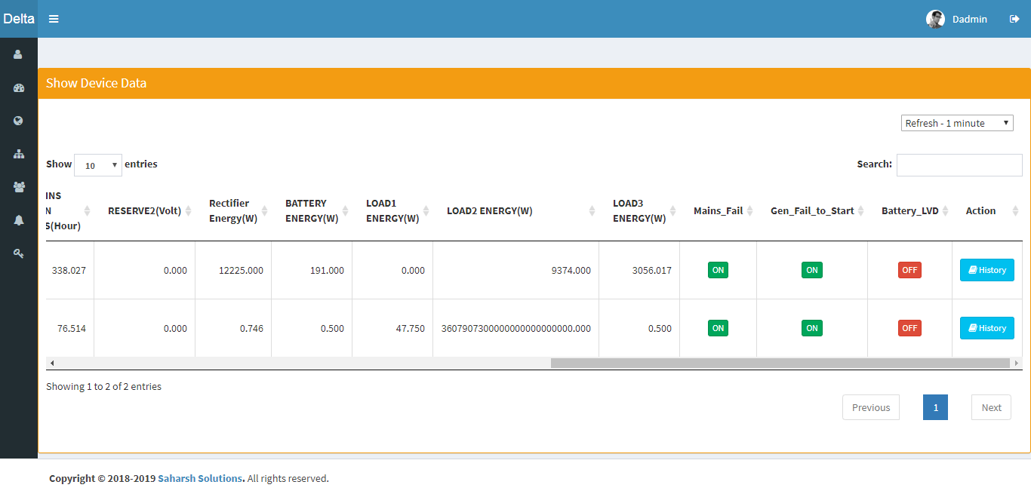

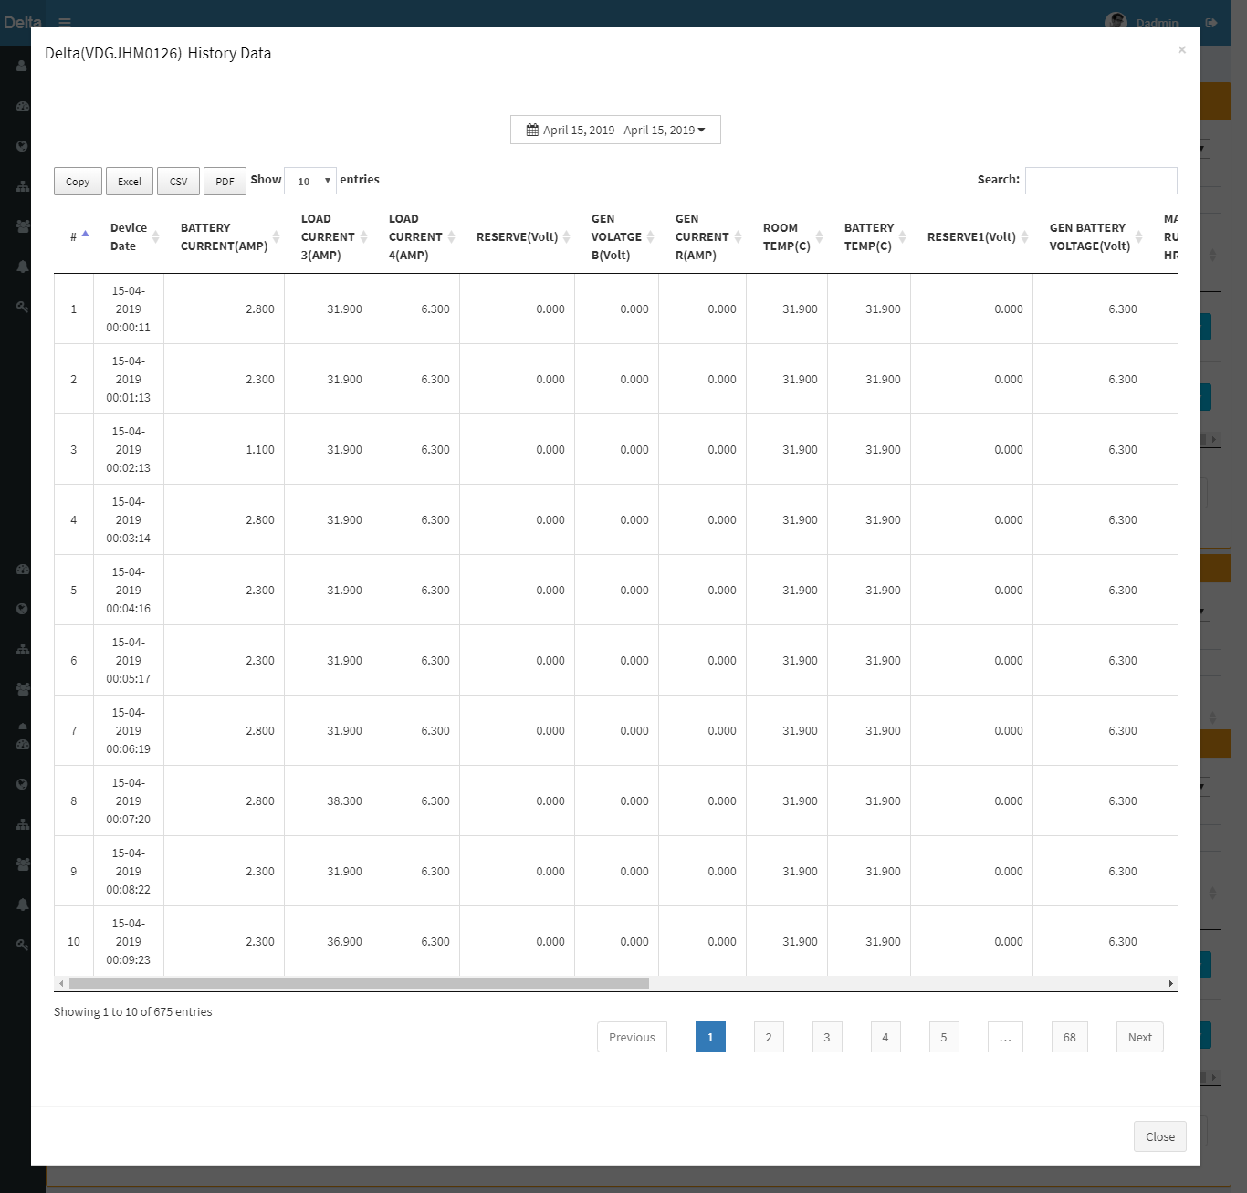

c)All Site List:-
It gives sitewise last track data of devices with view history functionality
and refresh feature.
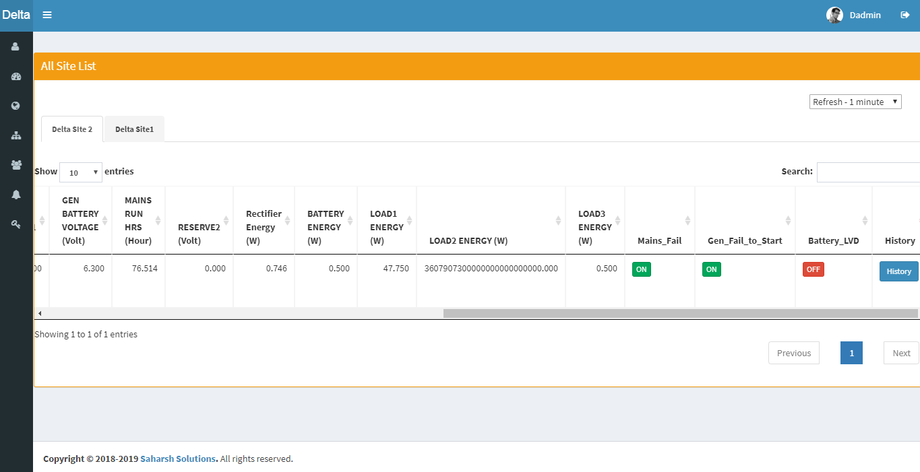

d)Site List:-
Manager can add,modify,delete,assign user and assign group to site.

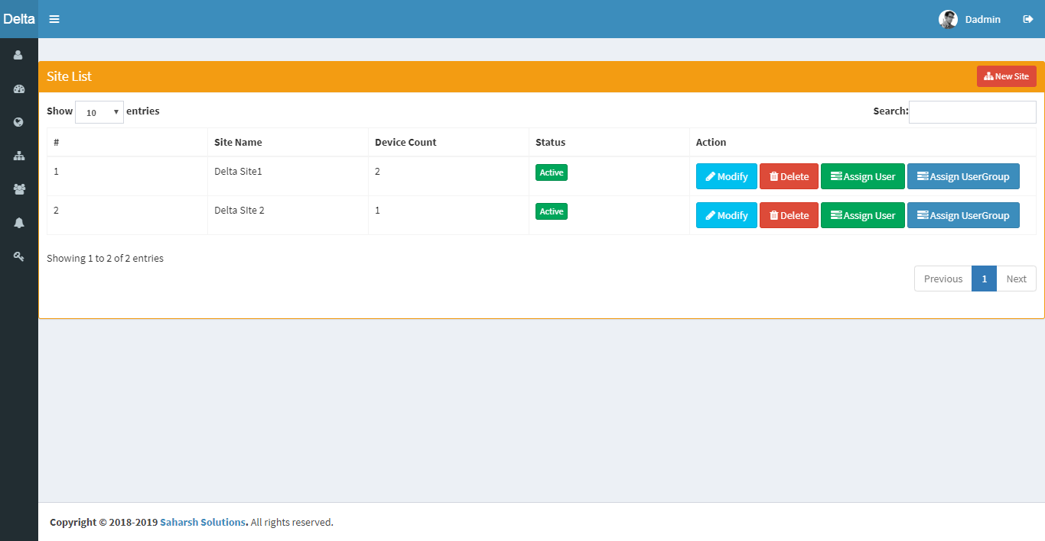

e)User Group List:-
It provides view of all user group with add,modify,delete and assign site
Site to user group feature.
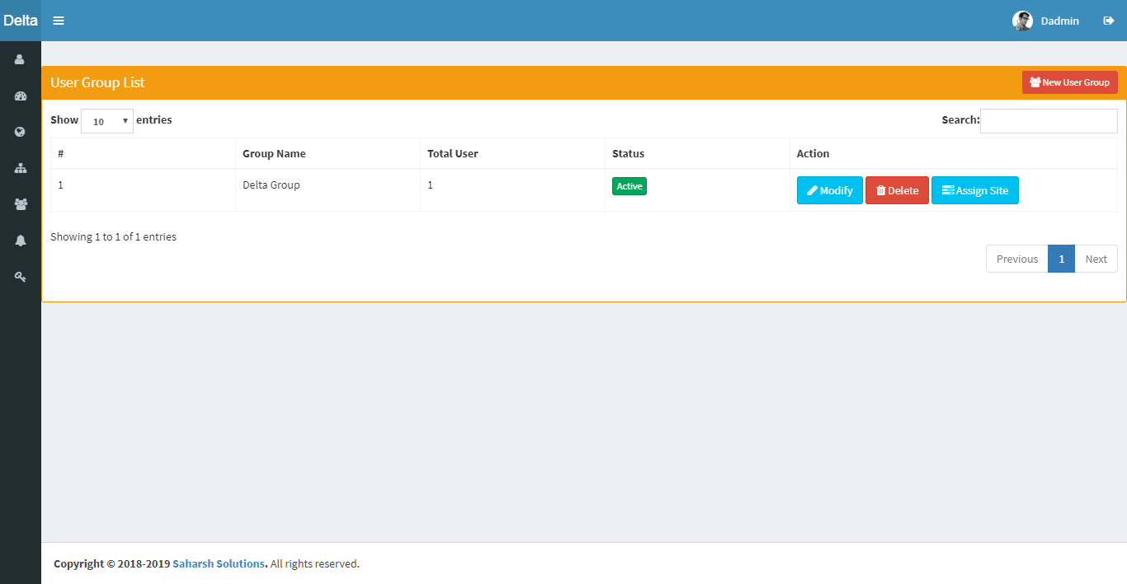

f)Digital Input Alert:-
Manager can add,edit and delete digital input alert to user,site,user group.

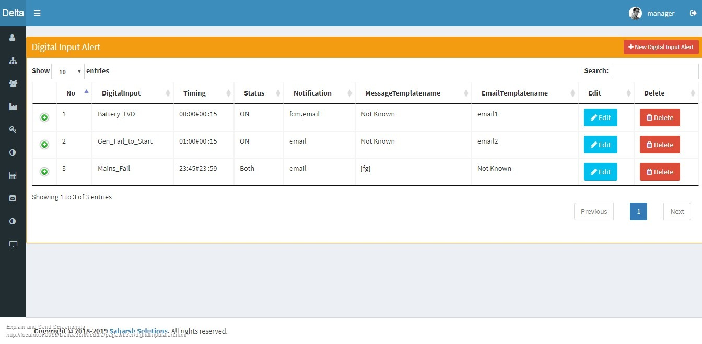

g)Reset password:-
Manager can reset its password for security reasons.
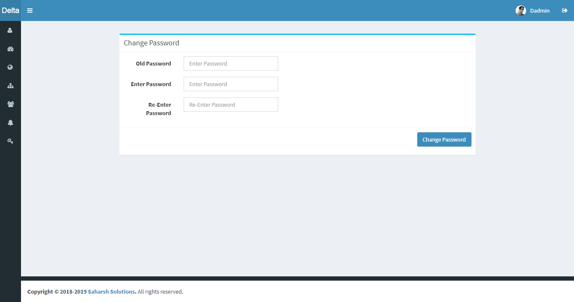

3)User Panel

User is last n customer who actually uses this device in their business.

Key features:

1)Individual Dashboard.
2)Report as per device parameter.
3)View of all device assign by manager.
4) Last Track and History of device.
5)Live Digital data and Site data.

a)Dashboards:-
Analog as well as digital dashboards has been Provided to analyse each
and every device parameter individually.

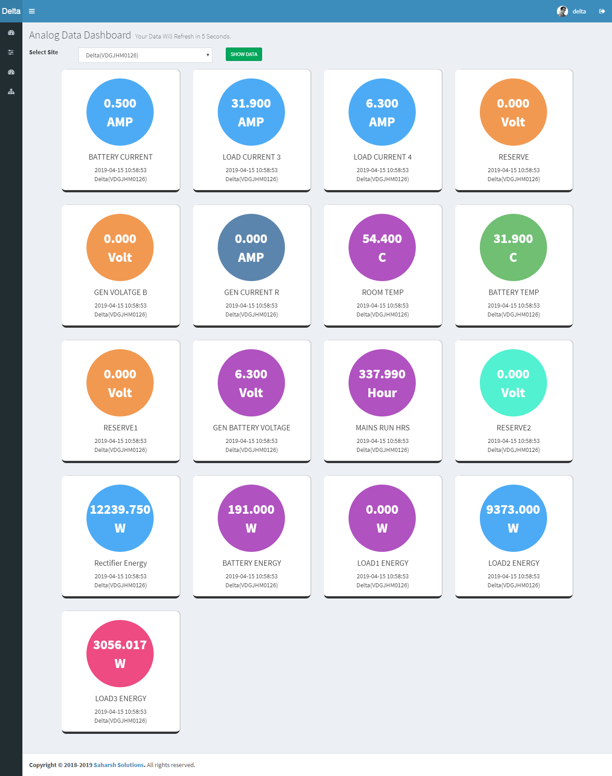

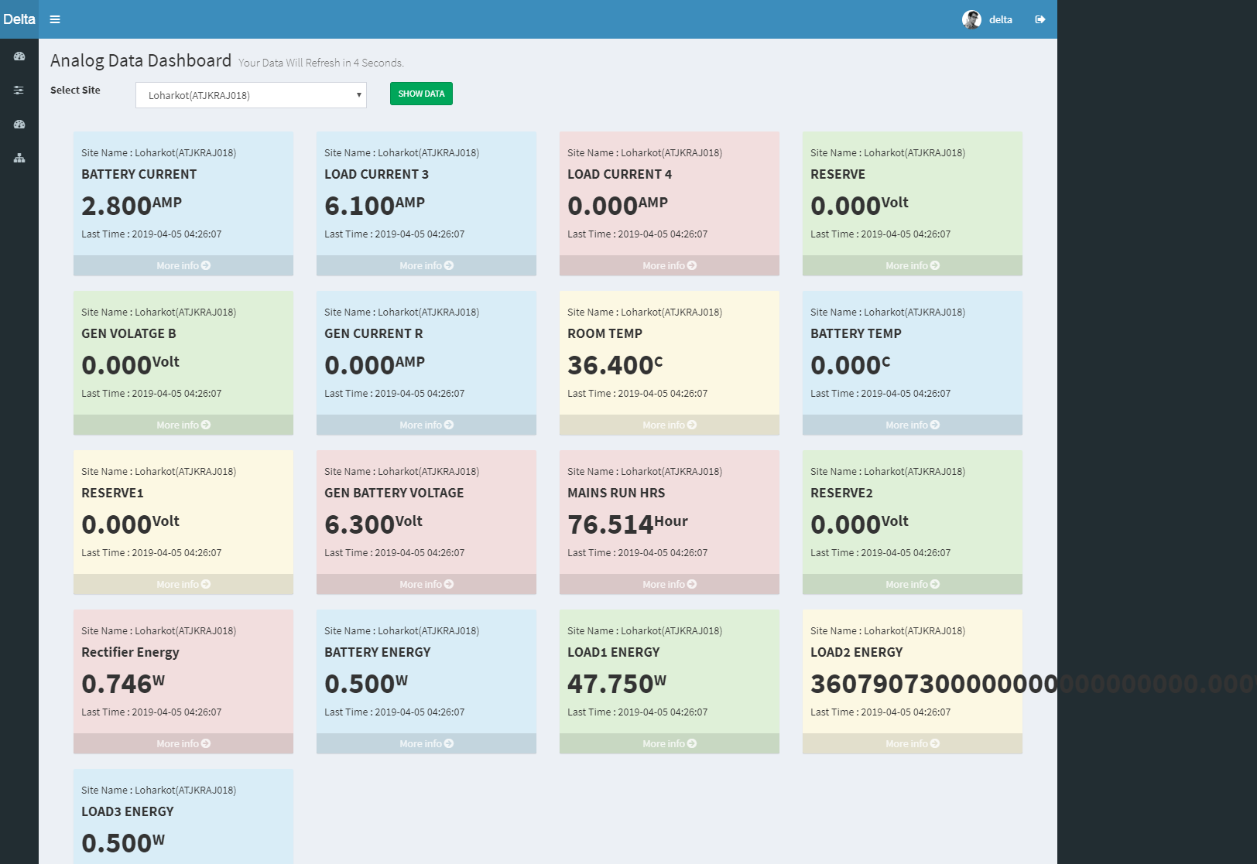

b)List Digital Data:-
It provides live digital data of device as per their site.

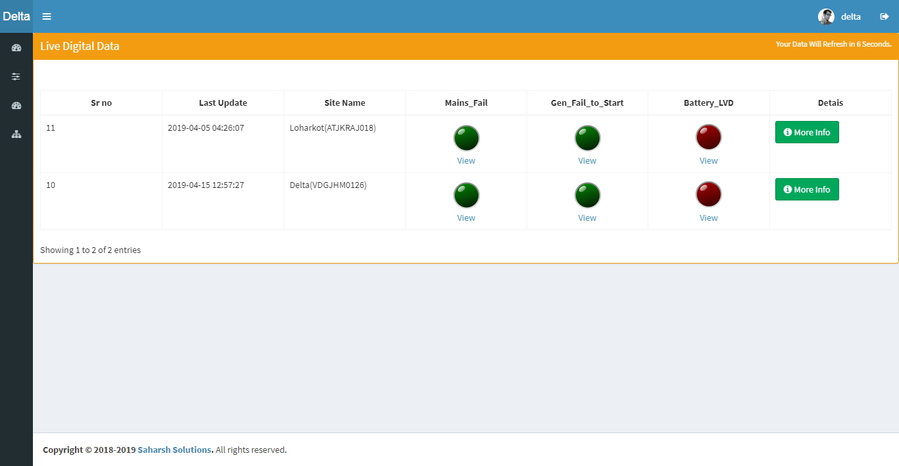
c)Show Device data:-
Devicewise last track data with history view is been provided to to user
panel to their working status.
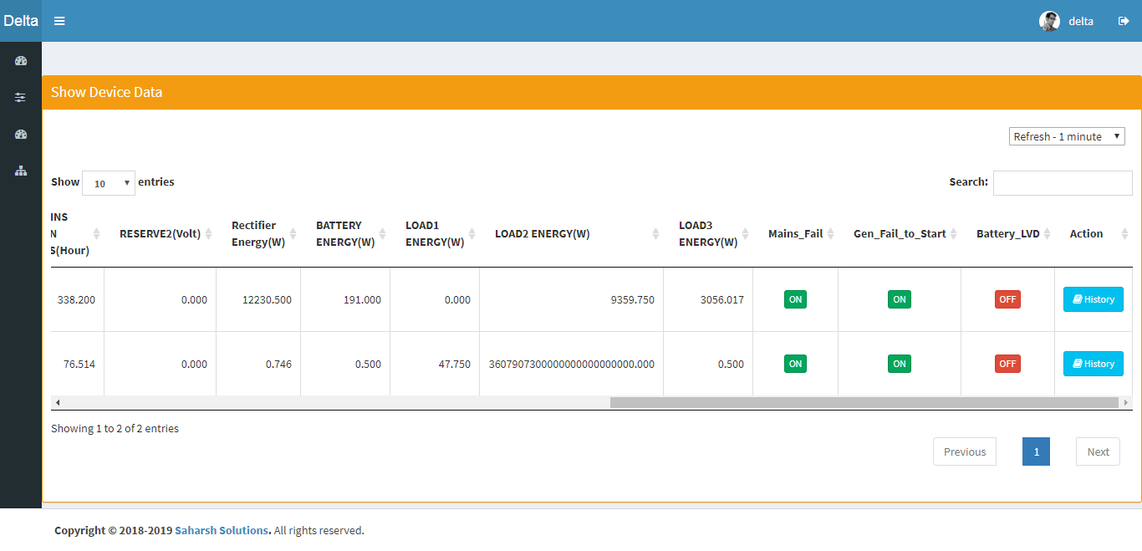

d)Assign Site List:-
Sitewise device data is been provide to user panel.
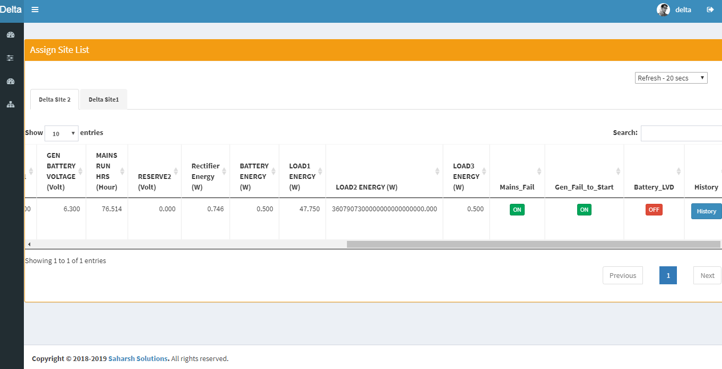

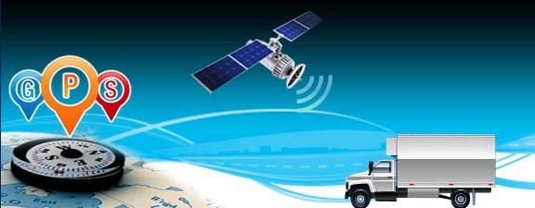

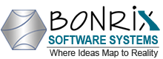
Contact No: 09624645500,09426045500 office: 079-26426364

Address : M/S. Bonrix Software Systems
A-801, Samudra Complex,
Near Klassic Gold Hotel, Off. C. G. Road, Navrangpura,
Ahmedabad - 380009, Gujarat, India.

Email Id:
bonrix@gmail.com

Websites:
http://Bonrix.in http://rechargesystem.bonrix.in http://pay.bonrix.in
http://bonrix.co.in http://biacon.bonrix.in http://crm.bonrix.in
http://gpstracker.bonrix.in http://android.bonrix.net http://salescloud.bonrix.in
http://myshoppingcart.bonrix.in

